Name: ______________________________________Index No: ________________________

School:_____________________________ Candidate’s Sign___________________

Date: ____________________________

443/1
AGRICULTURE
PAPER 1(THEORY)
JULY 2026
TIME: 2 HOURS

ARISE AND SHINE
TRIAL 2,TERM 2 EXAMINATION
Kenya Certificate of Secondary Education (K.C.S.E)

INSTRUCTIONS TO CANDIDATES:
- Write your name and index number in the space provided.
- Sign and write the date of examination in the space provided
- This paper consists of three section A, B and C.
- Answer all questions in section A and B.
- Answer any two questions in section C
- All the questions should be answered in the spaces provided.

FOR EXAMINERS USE ONLY
SECTION | QUESTINS | MAX SCORE | CANDIDATES SCORE
A | 1-16 | 30
B | 17-20 | 20
C | 21 | 20
C | 22 | 20
C | 23 | 20
TOTAL |  | 90

SECTION A (30MARKS)
Answer all the questions in this section in the space provided.
- Give four advantages of intensive farming. (2mks)
………………………………………………………………………………………………………………………………………………………………………………………………………………………………………………………………………………………………………………………………………………………………………………………………………………….. ………………………………………….
- State four benefits of agroforestry to a maize crop. (2mks)
……………………………………………………………………………………………………………………………………………………………………………………………………………………………………………………………………………………………………………………………………………………………………………………………………………………………………………………………..
- Mention four practices carried out to maintain grass pastures (2 marks)
…………………………………………………………………………………………………………………
………………………………………………………………………………………………………………….
……………………………………………………………………………………… ………………………….
…………………………………………………………………………………………………………………..
- State four cultural ways of controlling couch grass (2mks)
……………………………………………………………………………………………………………………………………………………………………………………………………………………………………………………………………………………………………………………………………………………………………………………………..................................................................................................
- Name three sources of underground water (1½mks)
……………………………………………………………………………………………………………………………………………………………………………………………………………………………………………………………………………………………………………………………………………..
- State three causes of blossom end of rot in tomatoes (1½mks)
……………………………………………………………………………………………………………………………………………………………………………………………………………………………………………………………………………………………………………………………………………

- Give three qualities of a good green manuring plant (1½mks)
……………………………………………………………………………………………………………………………………………………………………………………………………………………………………………………………………………………………..........................................................................
- State four reasons for practicing minimum tillage. (2mks)
………………………………………………………………………………………………………………………………………………………………………………………………………………………………………………………………………………………………………………………………………………………………………………………………………………………………………………………… ….
- Give four methods commonly used for applying nitrogenous fertilizers (2mks)
………………………………………………………………………………………………………………………………………………………………………………………………………………………………………………………………………………………………………………………………………………………………………………………………………………………………………………………………
- Give three ways in which pastures are classified (1½mks)
………………………………………………………………………………………………………………………………………………………………………………………………………………………………………………………………………………………………………………………………………………
- State four ways in which land reforms can be implemented in Kenya. (2mks)
………………………………………………………………………………………………………………………………………………………………………………………………………………………………………………………………………………………………………………………………………………
- State four factors that determine the stage at which a crop is harvested. (2mks)
………………………………………………………………………………………………………………………………………………………………………………………………………………………………………………………………………………………………………………………………………………………………………………………………………….………………………………………………….
- Give four beneficial effects of weeds to a farmer. (2mks)
…………………………………………………………………………………………………………………………………………………………………………………………………………………………………………………………………………………………………………………………………………………………………………………………….………………………………………………………...………
- Give four advantages of practicing crop rotation. (2mks)
……………………………………………………………………………………………………………………………………………………………………………………………………………………………………………………………………………………………………………………………………………………………………………………………………………………………………………………………………………………………………………………………………………………………………………..
- Name four methods of controlling pests. (2mks)
……………………………………………………………………………………………………………………………………………………………………………………………………………………………………………………………………………………………………………………………………………………………………………………………………………………………………………………………..
- State 4 practices which improve light intensity in crop production. (2 mk)
……………………………………………………………………………………………………………………………………………………………………………………………………………………………………………………………………………………………………………………………………………………………………………………………………………………………………………………………..
………………………………………………………………………………………………………………………………………………………………………………………………………………………………………………………………………………………………………………………………………………
………………………………………………………………………………………………………………

SECTION B (20 MARKS)
Answer all the questions in this section in the spaces provided.
- The following illustrations show different production function curves in agricultural economics. Study them and answer the questions which follows;
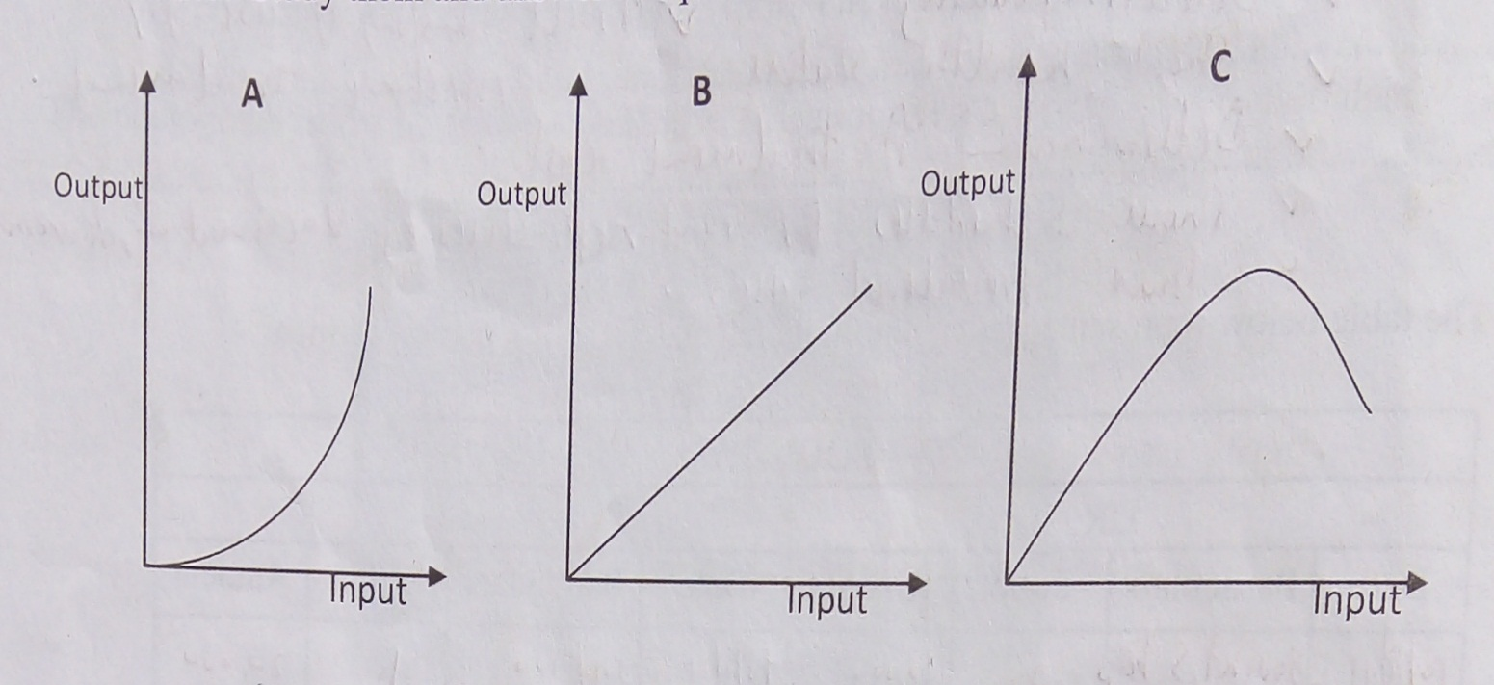

- Identify the production function curves labeled A, B and C
A …………………...………………………………………………………….. (1mk)
B ……………………….……………………………………………………… (1mk)
C. ………………………………………………………………………………. (1mk)
- What does the law derived from the production function labeled C state? (1mk)
………………………………………………………………………………………………
- Which one of the three production functions curves is rare in Agriculture (1mk)
…………………………………………………………………………………………………..
- The table below shows the population and gross domestic products of countries A and B
Country | Gross Domestic product (million Ksh) | Population (million)
A | 1800 | 36
B | 1200 | 15

- Calculate the per capita income for each country show your working (2mks)
…………………………………………………………………………………………………………………………………………………………………………………………………………………………………………………………………………………………………………………………………………………………………………………...………………………………………….
- Which of the two countries is more developed economically (1mk)
…………………………………..…………………………………………………………………..
- Give a reason for your answer in (b) above (1mk)
………………………………………………………………………………………………………………………………………………………………………………………………………………
- How can agriculture increase the gross domestic product of a country (1mk)
…………………………………………………………………………………………………………………………..…………………………………………………………………………………….
- The illustration below indicates a type of soil and water conservation measure.
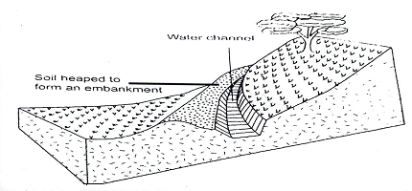
- Identify the structure illustrated above (1mk)
…………………………………………………………………………………………………………………………………………………………………………………………………………………..
- State two areas where the structure above discharges its water to. (2mks)
…………………………………………………………………………………………………………………………………………………………………………………………………………………….
- Apart from the above name two other structural soil and water conservation measures.(2mks)
.

- The diagram below shows a method of training crops
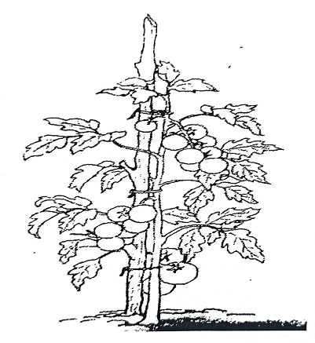
- Identify the method of crop training (1mk)
…………………………………………………………………………………………..
- Give two reasons why the practice is carried out. (2 mks)
…………………………………………………………………………………………..
- Other than the above method, give two other methods of training crops. (2 mks)
…………………………………………………………………………………………..
SECTION C
Answer any two questions in this section in the spaces provided after question.

- Explain five functions of a live fence in a farm. (5mks)
- Describe various risks and uncertainties in crop farming (10mks)
- Outline five factors that quicken the rooting of cuttings (5mks)

The following entries were obtained from Mrs.Wamarua’s farm for the year 2023
The opening valuation of the farm was Ksh.60, 000
Closing valuation as at 31st December 2023 was Ksh.90, 000
Wages paid was Ksh.50, 000
Equipment bought worth Ksh.70, 000
Drugs bought worth Ksh 25,000
Pig feeds purchased was Kshs.30, 000
The farm made the following sales during the year
Pig sales Ksh 70,000
Maize sales Ksh.42, 000

(10mks)
- Prepare the profit and Loss Account for Mrs.Wamarua’s Farm for the year ended 31st December 2023 (8mks)
- Did Mrs.Wamarua make a profit or loss? (1mk)

- Explain the different ways in which each of the following environmental factors influence crop production
(i) Wind (8 mks)
(ii) Temperature (5mks)

- Outline the information contained in a purchase order. (5mks)
- Describe the harvesting of tea (7mks)
- Explain the cultural methods of controlling soil erosion (8mks)

